**Gaussian Plume Modelling – SUMAS 2 Screening**

A coal fired power (SUMAS 2) station was proposed (but not built) 10 km south of Abbotsford on the USA side of the border (Image 1). There was concern that the plume would directly impinge on Sumas mountain (10 km away). This study applies the Gaussian Plume model in screening mode, to determine the predicted impact of this facility in a worst-case scenario; that is, at low wind speeds and no dispersion in the crosswind direction. Other details for this scenario are as follows:

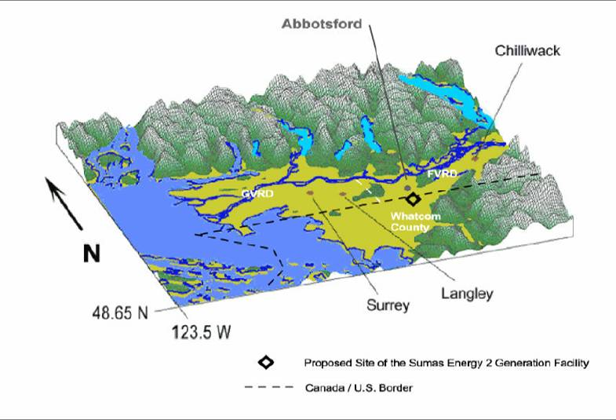

Image 1: SUMAS 2 Power station proposed site

* Stack Diameter = 3m

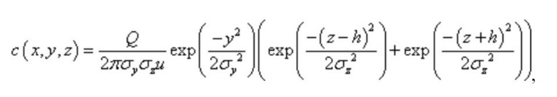

Image 2: Gaussian-Plume Equation

* Plume Exit Velocity = 6m/s
* Plume Exit Temperature = 350K (77oC)
* Ambient air temperature= 293K (20oC)
* PM10 Emission rate = 15 g/s
* Downwind Distance = 10,000 m
* Average wind speed – 1 m/s
* Effective Stack Height – 55m

The general equation for the Gaussian Equation is given in Image 2, where c is the pollutant concentration at one point. It is also important to note that the model is not time dependent and an average instead. Therefore, to screen for maximum concentration along the vertical profile, 10 km from the proposed site, the Gaussian Point Source Plume Model was run for an x of 10,000m, y of 0 and z of different heights between 1 to 400m. Table 1 summarizes the concentrations found at different heights along different stability classes. The classes are defined by the Pasquill Scale.

Table 1: Modelled concentration with height, for each stability class. A - Very Unstable, B- Moderately Unstable, C- Slightly Unstable, D- Neutral, E - Somewhat Stable, F- Stable

|  |  |  |  |  |  |  |
| --- | --- | --- | --- | --- | --- | --- |
| Height (m) | Concentrations (µg m-3) | | | | | |
|  | **A** | **B** | **C** | **D** | **E** | **F** |
| 1 | 0.010037 | 2.973107 | 11.523 | 60.10191 | 117.5259 | 192.9522 |
| 41 | 0.002273 | 0.673617 | 2.622966 | 14.66356 | 33.07409 | 82.19874 |
| 81 | 0.001731 | 0.512952 | 1.995718 | 11.02122 | 24.24023 | 55.9936 |
| 121 | 0.001474 | 0.436445 | 1.687377 | 8.483733 | 15.3818 | 20.27667 |
| 161 | 0.001315 | 0.388609 | 1.484824 | 6.264039 | 7.914856 | 3.655808 |
| 201 | 0.001203 | 0.354645 | 1.331841 | 4.345067 | 3.234509 | 0.321413 |
| 241 | 0.001119 | 0.328641 | 1.206412 | 2.805204 | 1.040051 | 0.013652 |
| 281 | 0.001052 | 0.307702 | 1.098089 | 1.677226 | 0.261828 | 0.000279 |
| 321 | 0.000998 | 0.290218 | 1.001341 | 0.925937 | 0.051451 | 2.73E-06 |
| 361 | 0.000952 | 0.27521 | 0.913043 | 0.471081 | 0.007877 | 1.28E-08 |
| 401 | 0.000913 | 0.262046 | 0.831366 | 0.220578 | 0.000938 | 2.85E-11 |

From table 1 we can see that the highest concentrations are seen at ground level, in stable atmospheric conditions (Class F), at approximately 193 µg m-3. In general the highest concentrations are seen at ground level in each class. It is also notable that stability class F also sees the highest variability in concentration. The lowest concentrations as well as variability as seen by class A. This also establishes a trend that the variability increases as we move from an unstable to more stable atmosphere.

The graph in Image 3 shows that the highest concentrations occur at ground level in each of the stability regimes and decrease as height increases. Image 3 is Gaussian Plume model run in MATLAB, with a rural terrain setting, with the same parameters described as default for our scenario.

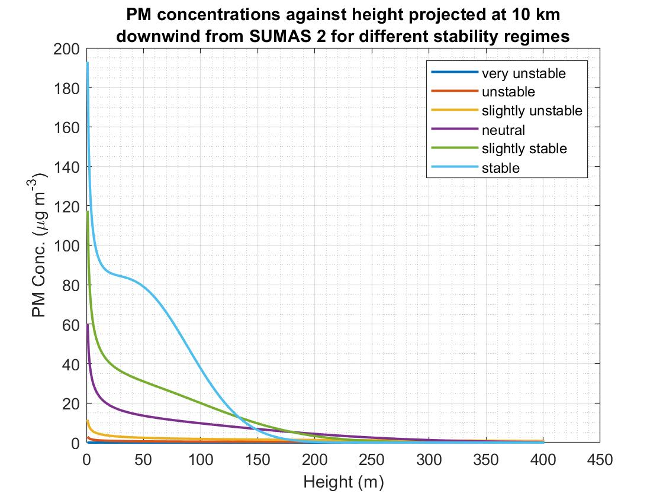

Image 3: Graph of PM concentration VS Vertical Distance for a Gaussian-Plume model

The highest concentrations are seen during stable conditions. If the plume was intercepted by an obstacle such as Sumas Mountain at 10km downwind from the source, it will result in plume impingement and the concentration levels will be highest at ground level. The concentration at the peak of Sumas Mountain (400m) is close to 0 for all stability classes. In case of classes A,B,C and F the concentrations reach zero before even 200m in height. Unstable conditions have relatively low concentrations throughout. It could occur due to looping of the plume as well as high convective mixing, and therefore the low variability is better justified. Under stable atmospheric conditions, the smoke plume tends to have an anisotropic coning dispersion and there is less convective mixing of the pollutants. Therefore, concentrations tend to be higher near the ground level, especially under light wind conditions. The predicted concentrations were also significantly high due to limitation of the Gaussian Plume Model. Gaussian-plume models break down for low wind speeds and produce the worst-case dispersions, as well as overestimate for impingement effects in GLC since they do not account for turning or rising wind caused by the terrain itself. Low winds and stable conditions predict less dispersion and advection by wind.

During the time of the SUMAS 2 proposal, the provincial “acceptable” objective daily concentration of PM10 was 50 μgm-3 based on a 24-hour rolling average (McKendry, 2000). It is not unusual in the Lower Fraser Valley (LFV) to see spikes in hourly concentrations of PM10 of 200 µg m-3, especially during light winds conditions with the development of a stable nocturnal boundary layer. This corresponds with the predicted maximum concentrations in this study of 193 µg m-3 and compares to this value. The median values for PM10 concentrations from McKendry’s study seen in figure 2 are relatively low, between 10 to 20 µg m-3 (McKendry, 2000). The observed values of PM10 concentrations in the LFV are relatively low, with peak concentration usually coinciding with the morning and evening rush hour (McKendry, 2000). The predicted values from the model at 10km appears to exceed this value, as well as the CWS. The maximum predicted value of 193 µg m-3 is not uncommon in the hourly values observed but is an outlier when compared to the median range of values in McKendry’s paper. Once again, the possible explanation is the limitations of the model itself and therefore an overestimate is predicted.

References

Ian G. McKendry (2000) PM10 Levels in the Lower Fraser Valley, British Columbia, Canada: An Overview of Spatiotemporal Variations and Meteorological Controls, Journal of the Air & Waste Management Association, 50:3, 443-452, DOI: 10.1080/10473289.2000.10464025